MINOR PROJECT – Understanding DNA damage and repair
Lynch syndrome – Mismatch Repair Genes
- Introduction:
Lynch syndrome is an inherited cancer-predisposition syndrome caused mainly by pathogenic variants in genes responsible for DNA mismatch repair (MMR). It increases the risk of several cancers, particularly colorectal and endometrial cancers, as well as cancers of the ovary, stomach, small intestine, urinary tract, and some other organs. The major MMR genes associated with Lynch syndrome are MLH1, MSH2, MSH6, and PMS2, that acts as DNA “spell checkers”. Deletions affecting EPCAM can also cause Lynch syndrome by reducing expression of the nearby MSH2 gene by disrupting transcriptional termination by epigenetic silencing. Most Lynch syndrome variants are inherited in an autosomal dominant manner. Once mismatches are identified, downstream repair is facilitated by MutL complexes, including MutLα (MLH1 and PMS2), which functions as a key endonuclease in the repair process. (RAQUEL GÓMEZ-MOLINA, 2025)

- Normal genes and proteins:
The main proteins involved in mismatch repair include:
Gene | Protein | Main function
MLH1 | MLH1 | Forms complexes involved in coordinating mismatch repair
MSH2 | MSH2 | Partners with MSH6 or MSH3 to recognize DNA mismatches
MSH6 | MSH6 | Works with MSH2 to recognize base-base mismatches and small insertion/deletion loops
PMS2 | PMS2 | Partners with MLH1 and contributes to excision of the incorrectly replicated DNA strand

The normal MMR pathway: During DNA replication DNA polymerases occasionally insert an incorrect nucleotide or create a small insertion/deletion loop.
DNA replication → mismatch formation → mismatch recognition → recruitment of repair proteins → removal of incorrect DNA → DNA resynthesis → ligation
The MSH2–MSH6 complex is particularly important for recognizing many types of replication errors. MLH1–PMS2 then helps coordinate the downstream repair process.

Figure 1. The process of DNA mismatch repair.
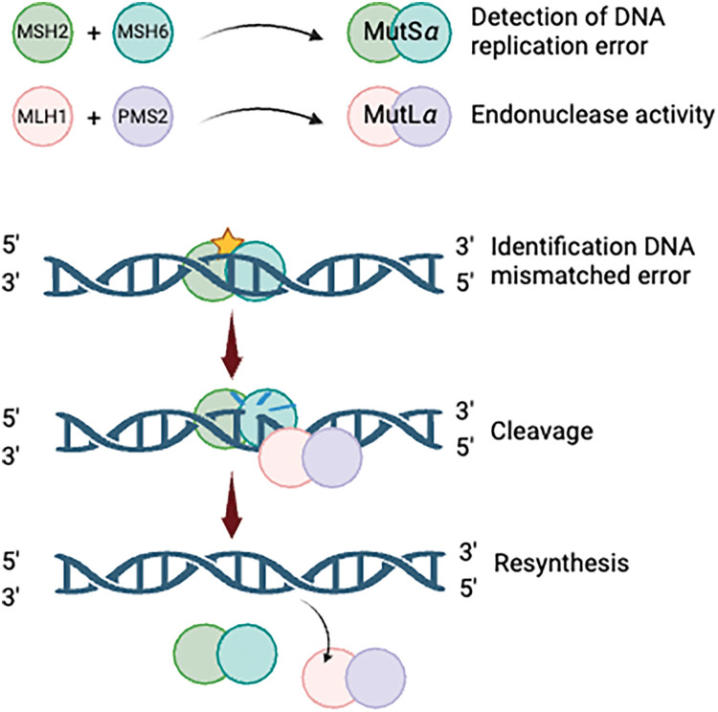

- Mutation:
- MLH 1: Located in chromosome 3, MLH1 heterodimerizes with PMS2 to form MutL alpha. It spans 19 exons. In addition, constitutional epimutation of MLH1 has been identified as an alternative mechanism that predisposes to LS . Founder mutations have been described in the literature, including an exon 16 deletion caused by an Alu-mediated recombination event.
- MSH6: Located in chromosome 2, MSH6 spans 10 exons. It heterodimerizes with MSH2 to form MutS alpha. (Jiricny, 2006; Li, 2008).
- EPCAM: This gene is located only 15 kb upstream of MSH2. Deletions encompassing the 3′ end of EPCAM without affecting the open reading frame of MSH2 result in epigenetic silencing of MSH2 via transcriptional read-through, resulting in promote hypermethylation and allele-specific gene silencing of MSH2 in EPCAM-expressing tissues . Deletions of EPCAM are associated with early-onset CRC but rarely with extra-gastrointestinal tumors.
A pathogenic mutation can alter the DNA sequence of an MMR gene and consequently affect the protein it produces.
For example:
Mutation in MLH1/MSH2/MSH6/PMS2
↓
Altered or absent protein
↓
Defective mismatch recognition or repair
↓
Accumulation of replication errors
↓
Increased mutation rate
↓
Genomic instability
↓
Increased probability of cancer development

Mutations may produce proteins that are truncated, unstable, incorrectly folded, or unable to interact properly with other MMR proteins. Some variants can also reduce the amount of functional protein produced.
When MMR is defective, errors that would normally be corrected remain in the genome. Repeated DNA sequences called microsatellites are particularly susceptible to these replication errors. This can result in microsatellite instability (MSI), an important molecular characteristic of many Lynch-associated tumors.

- Effect on functional proteins:
Consequences for DNA Repair:
Normally, MMR proteins recognize errors such as incorrectly paired bases or small insertion/deletion loops that occur during DNA replication.
In Lynch syndrome: Replication error
→ MSH2–MSH6/MSH2–MSH3 recognition is impaired
→ MLH1–PMS2-mediated repair is impaired
→ DNA mismatch remains unrepaired
→ Mutations accumulate
Pathogenic mutation in MMR gene
↓
Defective/ absent MMR protein
↓
Impaired mismatched repair
↓
Accumulation of DNA replication errors
↓
Microsatellite instability & genomic instability
↓
Increased risk of cancer.

- DNA Repair:
Cells possess several DNA-repair pathways because DNA is continuously damaged by replication errors, chemical agents, radiation, and normal cellular processes.
Important pathways include:
- Mismatch repair (MMR) – corrects replication errors such as mismatched bases and small insertion/deletion loops.
- Base excision repair (BER) – repairs small, chemically modified bases.
- Nucleotide excision repair (NER) – removes bulky DNA lesions.
- Homologous recombination (HR) – repairs DNA double-strand breaks using a homologous DNA template.
- Non-homologous end joining (NHEJ) – repairs DNA double-strand breaks by directly joining DNA ends.

- HRs vs NEHJ:
Both Homologous Recombination and Non- homologous end joining repair DNA double strand breaks but use different mechanisms.

Feature | Homologous Recombination (HR) | Non-Homologous End Joining (NHEJ)
Repair template | Uses a homologous DNA sequence | Does not require a homologous template
Accuracy | Generally high fidelity | Can introduce small insertions/deletions
Cell-cycle preference | Mainly S/G2 phase | Active throughout much of the cell cycle
Major proteins | BRCA1, BRCA2, RAD51 and others | Ku70/Ku80, DNA-PKcs, XRCC4, Ligase IV
Mechanism | DNA end processing and strand invasion followed by template-directed repair | DNA ends are processed and directly ligated
Main advantage | Accurate restoration of sequence | Rapid repair of broken DNA ends

- Conclusion:
Lynch syndrome demonstrates the importance of DNA repair in preventing the accumulation of genetic abnormalities. Mutations affecting MLH1, MSH2, MSH6, or PMS2 can disrupt the mismatch-repair pathway, allowing replication errors to persist and producing microsatellite instability and genomic instability.
More broadly, DNA-repair pathways such as MMR, BER, NER, HR, and NHEJ protect cells from different types of DNA damage. Maintaining effective DNA repair is therefore essential for preserving genome stability and reducing the accumulation of mutations that can contribute to cancer development.

REFERENCES
  - RAQUEL GÓMEZ-MOLINA , RAQUEL MARTÍNEZ. “Lynch syndrome and colorectal cancer: A review of current perspectives in molecular genetics and clinical strategies.” 2025 Jun 26;33(7):1531–1545.
doi: 10.32604/or.2025.063951
  - Idos, G., & Valle, L. (2026). Lynch syndrome. In GeneReviews. University of Washington, Seattle. https://www.ncbi.nlm.nih.gov/books/NBK1211/
  - Jiricny, J. (2006). The multifaceted mismatch-repair system. Nature Reviews Molecular Cell Biology, 7(5), 335–346. doi:10.1038/nrm1907
  - Li, G. M. (2008). Mechanisms and functions of DNA mismatch repair. Cell Research, 18(1), 85–98. doi:10.1038/cr.2007.115

